Supplementary Table 1. Comparison of patient demographics and disease characteristics between patients in and not in clinical remission at time of therapeutic drug monitoring for vedolizumab. FDR, false discovery rate.
 | Clinical Remission  (n=57) | Not in Clinical Remission  (n=16) | p-value | FDR  p-value
Median age, years (IQR) | 37.8 (27.3-57.9) | 32.8 (27.2-53.4) | 0.59 | 0.79
Male gender, n (%) | 32 (56.1) | 7 (43.8) | 0.38 | 0.67
Median disease duration, years (IQR) | 11.9 (7.0-18.9) | 15 (8.8-26.3) | 0.31 | 0.64
Diagnosis of CD, n (%) | 31 (54.4) | 12 (75.0) | 0.50 | 0.78
Active smoking, n (%) | 6 (10.5) | 2 (12.5) | 0.82 | 0.96
Previous anti-TNF exposure, n (%) | 27 (47.4) | 13 (81.3) | 0.02 | 0.14
Concomitant immunomodulator, n (%) | 11 (19.3) | 4 (25.0) | 0.62 | 0.79
Median duration on vedolizumab, years (IQR) | 1.6 (0.8-2.1) | 1.4 (0.9-2.5) | 0.97 | 0.97
4-weekly dosing, n (%) | 7 (12.3) | 7 (43.8) | <0.01 | <0.01
Median BMI (IQR) | 25.4 (22.7-29.0) | 25.7 (18.7-32.8) | 0.97 | 0.97
Median Albumin, g/dL (IQR) | 36.0 (34.0-38.0) | 34.0 (31.3-36.8) | 0.04 | 0.19
Median CRP, mg/L (IQR) | 3.0 (1.0-4.5) | 4.0 (1.3-11.0) | 0.17 | 0.60
Median FC, µg/g (IQR) | 62.0 (20.0-447.0) | 130.0 (55.5-529.3) | 0.32 | 0.64
Biologic remission, n (%) | 33 (57.9) | 7 (43.8) | 0.32 | 0.64
Supplementary Table 2. Comparison of patient demographics and disease characteristics between patients in and not in biologic remission at time of therapeutic drug monitoring for vedolizumab. FDR, false discovery rate.
 | Biologic Remission  (n=40) | Not in Biologic Remission  (n=33) | p-value | FDR  p-value
Median age, years (IQR) | 34.5 (25.8-49.6) | 40.8 (29.0-62.1) | 0.32 | 0.48
Male gender, n (%) | 19 (47.5) | 20 (60.6) | 0.26 | 0.48
Median disease duration, years (IQR) | 12.5 (8.2-20.8) | 8.9 (6.4-18.9) | 0.44 | 0.54
Diagnosis of CD, n (%) | 22 (55.0) | 21 (63.6) | 0.45 | 0.54
Active smoking, n (%) | 3 (7.5) | 5 (15.2) | 0.30 | 0.48
Previous anti-TNF exposure, n (%) | 22 (55.0) | 18 (54.5) | 0.97 | 0.97
Concomitant immunomodulator, n (%) | 5 (12.5) | 10 (30.3) | 0.06 | 0.24
Median duration on vedolizumab, years (IQR) | 1.6 (1.0-2.3) | 1.3 (0.7-1.9) | 0.12 | 0.36
4-weekly dosing, n (%) | 3 (7.5) | 11 (33.3) | <0.01 | <0.01
Median BMI (IQR) | 25.0 (22.5-29.0) | 26.2 (22.3-31.7) | 0.82 | 0.90
Median Albumin, g/dL (IQR) | 37.5 (35.3-39.0) | 35.0 (32.0-36.0) | <0.01 | <0.01
Clinical remission, n (%) | 33 (82.5) | 24 (72.7) | 0.32 | 0.48

Supplementary Table 3. Comparison of patient demographics and disease characteristics between patients in and not in endoscopic remission +/- 8 weeks from therapeutic drug monitoring for vedolizumab. FDR, false discovery rate.

 | Endoscopic Remission  (n=14) | Not in Endoscopic Remission  (n=26) | p-value | FDR  p-value
Median age, years (IQR) | 43.2 (31.0-60.8) | 35.9 (28.7-61.7) | 0.66 | 0.78
Male gender, n (%) | 7 (50.0) | 13 (50.0) | 0.99 | 0.99
Median disease duration, years (IQR) | 15.9 (10.0-19.9) | 12.0 (5.9-29.0) | 0.43 | 0.77
Diagnosis of CD, n (%) | 6 (42.9) | 16 (61.5) | 0.26 | 0.56
Active smoking, n (%) | 1 (7.1) | 6 (23.1) | 0.21 | 0.56
Previous anti-TNF exposure, n (%) | 8 (57.1) | 16 (61.5) | 0.79 | 0.86
Concomitant immunomodulator, n (%) | 5 (35.7) | 5 (19.2) | 0.25 | 0.56
Median duration on vedolizumab, years (IQR) | 1.1 (0.6-2.0) | 1.4 (0.8-2.3) | 0.63 | 0.78
4-weekly dosing, n (%) | 1 (7.1) | 8 (30.8) | 0.09 | 0.56
Median BMI (IQR) | 26.7 (24.0-40.0) | 25.0 (22.2-30.0) | 0.13 | 0.56
Median Albumin, g/dL (IQR) | 35.5 (33.8-37.3) | 34.5 (32.8-37.0) | 0.48 | 0.77
Clinical remission, n (%) | 10 (71.4) | 16 (61.5) | 0.53 | 0.77
Biologic remission, n (%) | 12 (85.7) | 7 (26.9) | <0.01 | <0.01

Supplementary Table 4. Comparison of patient demographics and disease characteristics between patients in and not in deep remission +/- 8 weeks from therapeutic drug monitoring for vedolizumab. FDR, false discovery rate.

 | Deep Remission  (n=10) | Not in Deep Remission  (n=30) | p-value | FDR  p-value
Median age, years (IQR) | 52.0 (31.0-67.6) | 35.9 (29.0-60.3) | 0.38 | 0.65
Male gender, n (%) | 6 (60.0) | 7 (23.3) | 0.03 | 0.15
Median disease duration, years (IQR) | 16.3 (10.9-19.9) | 12.0 (6.7-28.3) | 0.49 | 0.65
Diagnosis of CD, n (%) | 3 (30.0) | 20 (66.7) | 0.04 | 0.15
Active smoking, n (%) | 1 (10.0) | 3 (10.0) | 0.99 | 0.99
Previous anti-TNF exposure, n (%) | 4 (40.0) | 20 (66.7) | 0.14 | 0.34
Concomitant immunomodulator, n (%) | 3 (30.0) | 7 (23.3) | 0.67 | 0.80
Median duration on vedolizumab, years (IQR) | 1.3 (0.6-2.0) | 1.3 (0.7-2.3) | 0.94 | 0.99
4-weekly dosing, n (%) | 0 | 9 (30.0) | 0.049 | 0.15
Median BMI (IQR) | 25.8 (23.1-41.4) | 25.1 (22.4-30.7) | 0.48 | 0.65
Median Albumin, g/dL (IQR) | 35.0 (33.8-38.0) | 35.0 (32.8-36.3) | 0.38 | 0.65
Biologic remission, n (%) | 9 (90.0) | 10 (33.3) | <0.01 | 0.02

Supplementary Figure 1. Association of trough vedolizumab levels with (A) clinical remission; (B) biologic remission; (C) endoscopic remission; and (D) deep remission after omitting patients on 4-weekly dosing. Violin plots show median (solid line), interquartile range (dotted line), maximum and minimum.

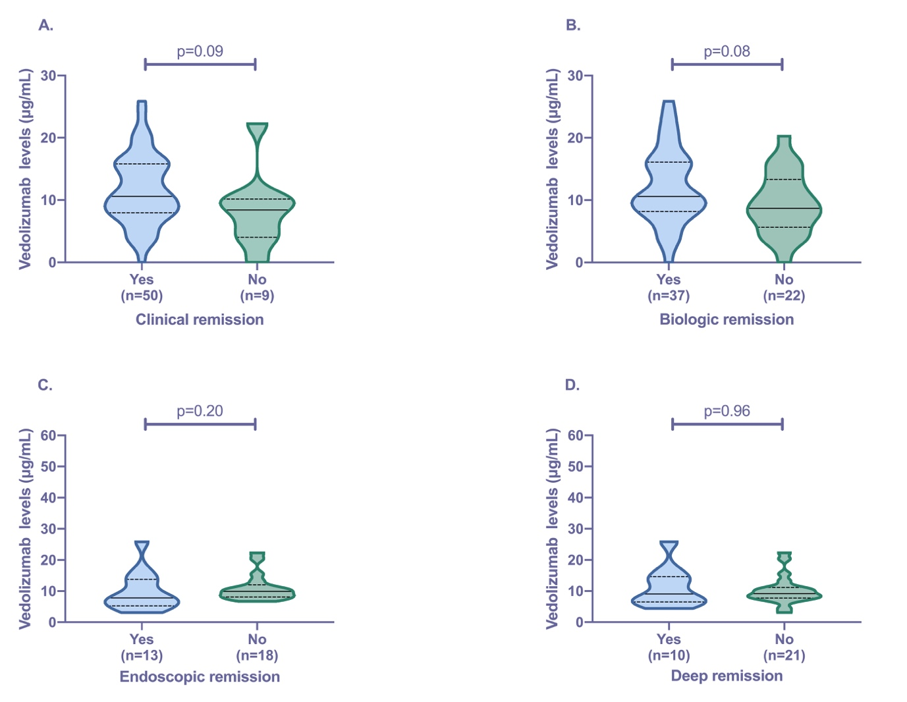

Supplementary Figure 2. Association of trough vedolizumab levels with (A) biologic remission defined as CRP< 5mg/L plus faecal calprotectin <150 µg/g and (B) biologic remission defined as CRP< 5mg/L plus faecal calprotectin <50 µg/g. Violin plots show median (solid line), interquartile range (dotted line), maximum and minimum.

